Experiment 5: Use Google and WHOIS for Reconnaissance
Aim: To gather publicly available domain registration information about a website using the WHOIS lookup service.
Procedure:
- Open Google Chrome in the Windows operating system.
- Search for the WHOIS website at who.is.
- Enter the target website domain, such as saveetha.com.
- Click the search option to retrieve the domain information.
- Examine the available details, such as domain registration, registrar, creation date, and expiry date.
- Record the information displayed by the WHOIS service.
Screenshots:
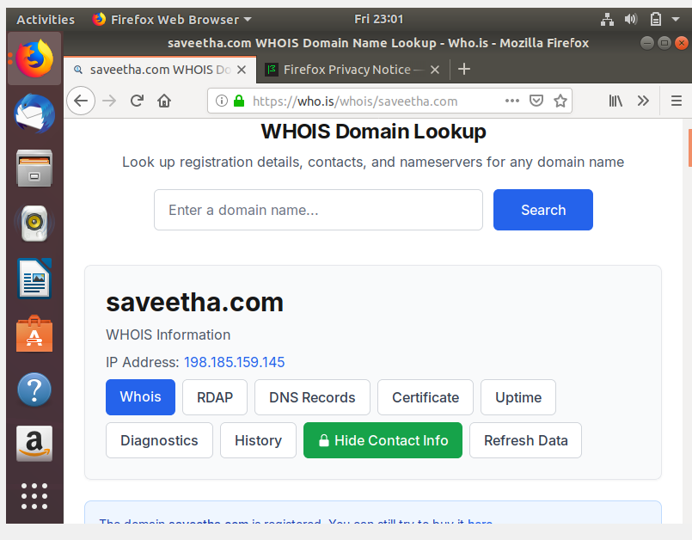

Result:
Thus, website reconnaissance was performed using the WHOIS service, and publicly available domain registration information was collected.

